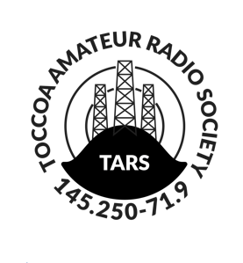**MEMBERSHIP APPLICATION**

Toccoa Amateur Radio Society

|  |  |
| --- | --- |
| New Membership | Renewal |

**Applicant Information:**

|  |  |  |  |  |  |  |
| --- | --- | --- | --- | --- | --- | --- |
| Application Date (mm/dd/yyyy): | | | | License Class:  Novice,  Technician,  General,  Advanced,  Extra | | |
| Amateur Call Sign: | | | |
| Name: | | | | | Date of Birth (mm/dd/yyyy): | |
| Address: | | | | | | |
| City: | State: | | Zip: | | | ARRL Member:  Y,  N,  Life |
| Email Address: | | Phone: | | | | Cell,  Work,  Home |

**Interests/Comments:**

|  |
| --- |
|  |

**Type of Membership** (choose one):

|  |  |
| --- | --- |
| Individual: $25.00 Annual | Senior (65 or older): $15.00 Annual |
| Associates: $12.50 Annual | Students (under 18 or full-time students): $5.00 Annual |

**Additional HAM Family Members** (residing at same address):

|  |  |
| --- | --- |
| Name: | License Class:  Novice,  Technician,  General,  Advanced,  Extra |
| Call Sign: |
| Date of Birth (mm/dd/yyyy): | ARRL Member:  Y,  N,  Life |

|  |  |
| --- | --- |
| Applicant Signature: | Date (mm/dd/yyyy): |

**I agree to abide by the By-Laws of the Toccoa Amateur Radio Society Inc. and I understand that the membership is subject to the approval of the club and the Board of Directors.**

**Please return this form to:**

Toccoa Amateur Radio Society

P.O. Box 2165

Toccoa, GA 30577